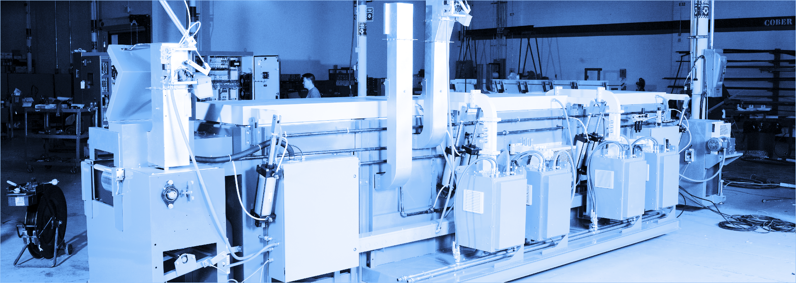

Cober Insights

Project Proposal by

….

Tom Birmingham,

Neha Nadkarni and

Komal Ghugare

Cober, Inc.

30 Maffitt St.

Stratford, Connecticut

06615

[ this page left intentionally blank ]

**TABLE OF CONTENTS**

**DELIVERABLES** **4**

PURPOSE STATEMENT 4

SCOPE STATEMENT 5

FEASIBILITY STUDY 9

PROJECT CHARTER 10

PROJECT PHASES & METHODOLOGY 12

STAKEHOLDER DEFINITIONS & ANALYSIS 14

PROCESS GROUPS DEFINITION 16

PROCESS DEFINITION MATRIX 17

PROJECT SCHEDULE & TIMELINE 18

RESOURCE DEFINITION & ALLOCATION 22

MEMBERSHIP ASSIGNMENT 23

PROJECT COST ESTIMATE 24

COST BENEFIT ANALYSIS 25

RISK ASSESSMENT 26

QUALITY ASSURANCE OVERVIEW 28

**Artifacts** **30**

SCOPE TABLE v2.1 30

PROCESS GROUP MATRIX v2.0 31

PROCESS METHODOLOGY & DEFINITION MATRIX V2.0 32

STAKEHOLDER POWER & INTEREST CHART v1.0 33

RESOURCE ALLOCATION v2.1 34

PROJECT COST ESTIMATION v2.0 35

RACI ARTIFACT v2.0 37

## 

# DELIVERABLES

## PURPOSE STATEMENT

**ABOUT COBER**

Cober is an expert in the design and manufacturing of industrial heating and precision drying systems, serving industries including automotive, food, pharmaceutical and more. Cober is also the leader in microwave vulcanization systems for the automotive industry. Please see examples of Cober equipment on our website: [https://www.cober.com](https://nam02.safelinks.protection.outlook.com/?url=https%3A%2F%2Fwww.cober.com&data=02%7C01%7Cbirmingham4%40southernct.edu%7Ced89cf4904e14e888b1508d6d7eae23d%7C58736863d60e40ce95c60723c7eaaf67%7C0%7C0%7C636933801146298328&sdata=sRlQx7f4sxolg8%2BT31cnsSZzYMUewNK27s6c5SFksYE%3D&reserved=0)

During customer operation of Cober’s heating systems and ovens, a large amount of process data is generated and can be of value to the customer. This data includes time, temperature, product information, alerts, operational history and detailed electrical information which is relevant to the operational health of the equipment. While much data is generated, Cober and Cober’s customers aren’t making optimal use of this data. Opportunities exist to provide this data in various formats along with a set of analytics to customers. This would provide the opportunity for Cober to increase the value delivered to customers from just machines to machines plus intelligence. The purpose of this project is to build out functionality in this area as a formal Industrial Internet of Things (IIoT) initiative.

**PROJECT PURPOSE**

Cober outfits it’s ovens and heating systems with IIoT data collection devices. The devices poll the machine’s programmable logic controllers (PLCs) to pull relevant operational data. Collected data will be transferred from the devices to the cloud on an ongoing basis. Once in the cloud the opportunity exists to provide the data to our customers as a service in various forms for various purposes.

Cober seeks to improve their customers experience by providing machine operational data to drive business intelligence. Cober will further improve upon their machines by collecting and analyzing machine operational data from all Cober clients.

The Cober Insights Project is seeking approval to plan, design, build, and implement a new data collection and analysis tool for Cober and Cober’s customers to track machine operational data and enable higher quality of engineering. Clients will have access to dashboards showing the operation of their machines in real-time, as well as historic reports of machines performance, logs of alerts and operator controls, and emailed alerts.

## 

# 

## SCOPE STATEMENT

This project scope serves as a framework for defining the purpose, requirements, strategy, boundaries, acceptance criteria and deliverables for the Cober Insights project. This completion date for this project is June 30, 2021.

**DESCRIPTION**

The scope of Cober Insights is to develop a more robust Internet Diagnostic Online (iDOL) hardware making Cober machines a pioneer in the Industrial Internet of Things (IIoT) field. High level details of the scope are:

1. build an analytics platform capable of displaying real-time metrics
2. develop an in-house data collection device to reduce reliance on third party product

Access and permission to manipulate data being tracked will be granted to specific Cober personal to update.

Access and permission to view client data will be managed by Cober personnel.

The application will incorporate a live dashboard showing machine output, such as set power, oven temperatures, water flow and more as defined by the client, in real-time. Reports and alerts can be scheduled based on key metrics.

**HIGH-LEVEL REQUIREMENTS**

* Database warehouse
* Cloud data security
* iDOL Application and interface (reports)
* End User feedback

**BOUNDARIES**

The project will include work specific to mapping, application and prototype designing, data analysis, dashboard analytics building, testing and implementing. For the requirements gathering, the project team intends to solicit feedback from department heads and trial users. Requirements will cover data points to be collected by existing Flexy data collection device, specs for an in-house data collection device, conceptual and logistical design of the database and user interface, along with cloud security and access.

Not included in this scope is the marketing and sales efforts of Data as a Service (DaaS), ongoing maintenance or upgrades for the Flexy device.

**STRATEGY**

The project team expects to leverage the expertise of the current Information Security and Information Technology staff for cloud security and hardware maintenance. Additional expertise will need to be hired in the fields of Software Development, UX/UI Designer and a Data Scientist.

For practical feedback, the project team will interview trial clients after a predetermined time one year period to find pain points in application/interface usage and identify if there are additional data fields that can be captured or calculated to provide further value to Cober and its clients.

**DELIVERABLES**

There are two main deliverables as a result of the completion of the Cober Insights project. If the following deliverables are not met then the project will not be considered successful. The Project Manager is responsible for ensuring the timely completion of these deliverables.

1. System & Application Development
2. A tested and operational in-house data collection device able to capture all points currently tracked by Flexy

|  |  |  |  |
| --- | --- | --- | --- |
| **SCOPE ARTIFACT v2.1** | | | |
| **Project Name** | Cober Insights | | |
| **Project Sponsor** | Mathew Krieger | **Project Manager** | Thomas Birmingham |
| **SCOPE DESCRIPTION** | The Cober Insights project consists of three phases. Phase 1 will consist of the development of an application compatible with the data collection device. Phase 2 will broken into two sub phases. Main subphase 2A will be the sourcing of additional talent to round out the project team as well as identifying existing clients to be trial clients. Phase 2B will be the collection of data for a one year period starting in Q2 2020. Phase 3 in conjunction with the data analysis, will see a technology investment at Cober for an in-house data collection device.  This project will allow Cober an advantage in the data as a service in the manufacturing sector adding value in the areas of predictive maintenance, process optimization and product output. Cober Insights will be completed June 30, 2021. | | |
| **PROJECT DELIVERABLES** | 1. System & Application accessible by clients for machine metrics 2. A tested and operational in-house data collection device able to capture all points currently tracked by Flexy | | |
| **REQUIREMENTS** | * Investment in technology and technology staffing * Data gathering and analysis to feed AI forecasting models * Willing and communicative trial clients | | |
| **ACCEPTANCE CRITERIA** | **Cober**   * Meet deliverables within time and budget * Gather one year of client data to be fed into application * Develop in-house data collection device no longer relying on Flexy * Faster proactive deployment of machine technicians   **Customer**   * Initial reduction in scrap by 1% within the first year of data gathered * Initial reduction in machine part failure by 2% over prior years servicing request * Reduce machine downtime by 5% at the end of year one years | | |
| **CONSTRAINTS** | **Time**: during the one year period of data gathering and analysis  **Budget**: additional resources and talent must be sourced outside Cober | | |
| **ASSUMPTIONS** | **Resources**: end user (client) will be able to test and provide feedback to Cober IT/Software developers during Phase 2  **Delivery**: data collection device software specifications will be catalogued within the next two months based on existing expertise  **Schedule**: sufficient data will be gathered in one year to allow for artificial intelligence and machine learning to generate forecasting events  **Technology**: 50% of software development can be completed by COBER IT/Software Developers, Electrical/Mechanical engineers and Machine technicians | | |

*figure #1 sample project scope artifact*

**ACCEPTANCE CRITERIA**

The acceptance criteria for the Cober Insights project covers both quality and quantity. The criteria to be met in order for a successful project are according to internal, Cober and external, customer stakeholders:

**COBER**

1. Meet deliverables within time and budget
2. Gather one year of client data to be fed into application
3. Develop in-house data collection device no longer relying on Flexy
4. Faster proactive deployment of machine technicians

**CUSTOMER**

1. Initial reduction in scrap by 1% within the first year of data gathered
2. Initial reduction in machine part failure by 2% over prior years servicing request
3. Reduce machine downtime by 5% at the end of year 1two years

**CONSTRAINTS**

A few constraints have been identified by the project team for the Cober Insights project. Considerations have been built into the project timeline but the project team will monitor and notify stakeholders of changes that may impact the project.

Stakeholders must be mindful of the constraints and work to minimize additional risk so as to reduce any negative effects on the timeframe, scope and budget of the project. Should a new risk pushing one or any of the constraints below be identified the stakeholder should immediately notify the project team.

The following resource constraints have been identified:

1. IT will need to hire skills/talent in the following areas Software Development, UX/UI design
2. Engineering department will need to hire skills/talent in the area of Computer Engineering
3. The company will need to hire a Manufacturing Data Scientist

## 

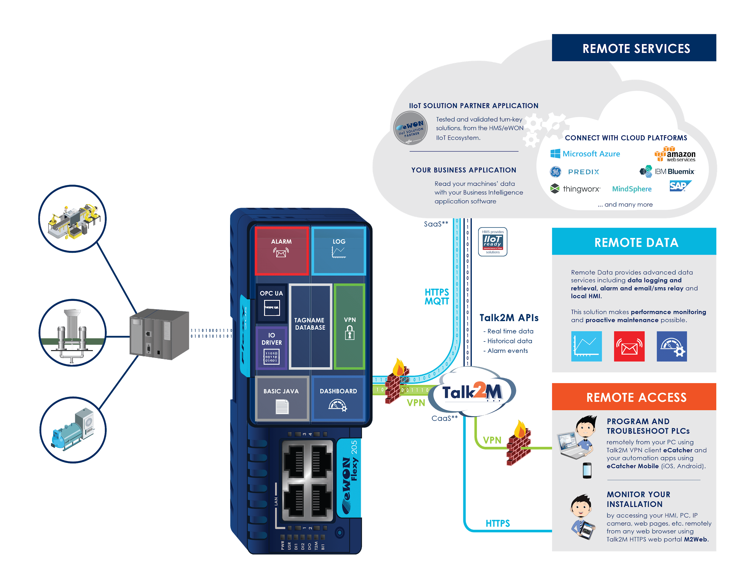

*figure 2. Flexy Data Integrations*

The image above demonstrates the data connections made by the eWON Flexy. Flexy receives data from machines’ PLCs as tags. Tags are written as a message in JSON format. Messages are sent via the IoT data protocol MQTT and landed in the cloud. Messages are stored for future analysis in Blob Storage.

## 

## FEASIBILITY STUDY

The feasibility study is concerned with the practicality of completing this technical project. Factors such as technical feasibility, economic feasibility and organizational feasibility are each taken into consideration.

**TECHNICAL FEASIBILITY**

Cober is a manufacturing equipment supplier which serves a variety of industries including automotive, infrastructure and construction, pharmaceutical and medical research, environmental, laboratory and science, food and more.  All these industries require heating processes that are closely-controlled, selective and precise. Data is collected and displayed back to the customers to increase the value they receive from Cober machines.

**DEVICE FAMILIARITY**

The customers have been using heating systems and ovens for quite a long time. This project aims to integrate a module, to collect data, inside the already existing heating systems so there won’t be any change in operating these systems. We don’t need to operate modules as they themselves collect the data.

**COMPATIBILITY**

Compatibility means that the operations of the existing system will not be affected by the addition of module. IIoT devices will be integrated in such a way that it is compatible with already existing technology. Hence, it will be easier for system to update and integrate to the new addition which will ensure a smooth transition into the new system.

**PROJECT SCOPE**

Keep one IT professional on board for maintenance of the system and future improvements.

**ORGANIZATIONAL FEASIBILITY**

This project mainly aims at increasing the value of delivered data by adding intelligence, for this purpose, company used IIoT devices. This system provides various features as live dashboard, historical reports, etc. which help the customer to transform their businesses to better scale; which intern results in rise in the number of customers that accelerates market value of organization.

**ECONOMIC FEASIBILITY**

The economic feasibility is concerned with costs of development and operation and the tangible and annual benefits.

**DEVELOPMENT COSTS**

* + The cost of website creation for admin report generation.
  + The cost for data integration will be high.
  + The main cost would be to purchase new equipment, specifically the cost of IIoT devices.

**OPERATING COSTS**

* The continuous cost of website operations and maintenance of website.
* The cost of labor for maintenance of IIoT devices. It would cost $25 per hour full time for each of the three IT professionals.
* The cost of using cloud server for storing data from IIoT devices. Initially it supports only three customers for $350 per month and later it increases to $500 per month.

**ANNUAL BENEFIT**

An estimate of 20% annual growth is expected in the business.

**TANGIBLE BENEFITS**

Customers can track and access data in centralized manner.

## PROJECT CHARTER

This project charter outlines the direction of the Cober Insights project and includes project objectives and management of objectives.

**ROLES AND RESPONSIBILITIES**

Tom Birmingham, Komal Ghugare and Neha Nadkarni are working remotely on the documentation and planning for the Cober Insights project. After the documentation is completed, project plans will be presented in front of a board of executives for approval.

**PROJECT OBJECTIVES**

The objective of the Insights project is to fulfill the business need and align with company strategic goals.

**BUSINESS NEED**

In today’s manufacturing world, factories are becoming “smarter” by becoming interconnected. Technologies exists which improve the optimization of factory equipment through data communications known as Industrial Internet Things (IIoT). The IIoT platform allows for greater efficiency, optimization, reduced scrap, less downtime and factory automation.

**ALIGNMENT WITH STRATEGIC GOALS**

The Cober Insights project aligns with Cober strategic goals, *sell more parts and improve customer experience.* The project enables Cober to sell more parts by increasing the lifespan of replaceable parts, and notifying customers when to order a replacement part before a part failure. Also, customer’s experience will be improved when using the system. Customers will be able to login to an application and view machine dashboards in real-time. Newer interfaces attract younger machine operators to work with Cober clients. And alerts enable factory managers and supervisors respond to problems as soon as they occur.

**SUCCESS CRITERIA (REQUIREMENTS)**

The Cober Insights project includes system and application development, data collection and analysis and marketing to existing and new Cober customers. The technology stack should include the following:

* A machine is fitted with a data collection router
* Data is sent to the cloud on an ongoing basis for storage and analysis
* An application allows Cober employees and Cober customers to login and access data and manage from the web.
* Dashboards allow users to view the operation of machines in real-time.
* Reports allow users to view historic data related to a machine or group of machines. Included is detailed electrical information for troubleshooting, machine lifespan, and a log of alarms and operator controls.
* Finally, when a machine experiences an alarm, an alert is sent as an email to a contact saved for a machine.

**APPROACH**

Cober will employ several IT and project professionals including: three Project Management Professionals, Software Developer, UI/UX designer, and IT Security Professional to develop and implement a prototype for the Insights system within the first quarter of 2020. After the prototype is complete, the system will be marketed to existing Cober clients to implement Insights and begin data collection. Data modeling will allow for the formation of business cases proving the value of the Cober system to new Cober clients. Cober Insights will be sold as a service from Cober to existing and new Cober customers. Finally, Cober will design and engineer their own proprietary data collection device.

## 

*figure 3. Dashboard Design*

In the screenshot above, a dashboard is designed to reflect the operation of a machine. This mockup presents the actual output of the project, an application which allows machine operators to view their machines running in real-time with dashboards and alerts.

## PROJECT PHASES & METHODOLOGY

Project phases and methodology is concerned with defining the logical phases of the project and methodologies selected to execute each phase.

**PHASE 1 | APPLICATION DEVELOPMENT**

In the first phase of the project, a system prototype (the actual data collection device [DCD] is provided by a third party Flexy). COBER is planning to make its own DCD in Phase 3. Currently, opportunities exist to collect and analyze the data to drive value in new ways which has not been completed before. Devices are available to connect a machine to the cloud. Software design and development is required to prove that an end-to-end solution exists to collect machines’ operational data and analyze it in the cloud.

**PHASE 2 | DATA SCIENCE**

After data collection is completed, the next logical phase of the project is to perform major analysis on the data collected utilizing artificial intelligence and machine learning (AI/ML). In order to leverage these technologies, a data model must be defined including data inputs and outputs. Outputs of the machine learning model include new data points that drive value for. Cober and Cober clients. Inputs of the model include the data points which have already been obtained by data collection.

**PHASE 3 | DATA COLLECTION DEVICE**

The next phase of the project is concerned with marketing the system to existing customers and new customers. Existing Cober customers could retrofit their machines with the data collection system. New Cober machines will come equipped with this feature with an additional charge for usage by new Cober customers.

**AGILE METHODOLOGY**

In Cober Insights project, it is expected to have a focus on helping teams in an evolving landscape and maintaining a focus on the rapid delivery of business value. The methodologies used in agile project management (Scrum, XP, Kanban) all follow the Agile Manifesto that is based on continuous improvement, flexibility, input of the team, and the delivery of results with high quality which stands out on Cober Insights expectations which is why agile methodology has been chosen for this project. Agile methodologies perfectly address customer’s needs. During the whole cycle, user involvement is encouraged, providing visibility & transparency, showing the actual progress of projects. Agile method is all about iteration which makes the project very easy to adapt when customer requirements change.

**FIVE STEPS OF AGILE:**

1. **CONCEPT & PLANNING**

The concept of Cober Industrial Internet of Things (IIoT) was processed so that customers could gain insights through data collected from their machines. For accessing the data customer needs to login to the developed web-based application. Each machine contains a data device known as eWON Flexy which collects the data from machine, send it to the cloud, process it and stores the data.

1. **REQUIREMENT ANALYSIS**

Client wants a software which can access their data from web-based application. So that the application will allow customers to view dashboards of their machines in real-time, historic reports for the day, week, month or year, and manage contact preferences for alerts. The client wants to view a report in Cober Insight application; their view should only be of machines they own which helps to maintain the security of clients’ organization.

1. **DESIGNING**

The web-based application is developed using HTML, JavaScript and CSS, besides a data gateway can collect and send the data via two protocols HTTP and MQTT. Data will be collected and sorted into arrays using tag names. Flexy first publishes the tags to Azure IoT hub, which acts an MQTT broker and receives messages from all Flexy routers. Once arrived in IT hub, messages are routed to several endpoints including service bus for alarms and blob storage for long term storage. The second destination where the tags are published is the Power BI, REST API’S which is done using an HTTP request, in this the tags from all generated is captured in JSON format and then directly published. The agile methodology helps in maintaining the transparency in the entire process.

1. **IMPLEMENTATION & BUILDING**

All application services will be deployed to the Microsoft Azure Cloud. Now, multiple machines from multiple companies connect to the Azure IoT Hub using MQTT protocol. Cober has multiple clients, with multiple machines, with multiple generators and tags. From Flexy, messages are sent to IoT Hub. From there, messages are routed to Service Bus for alerts and Blob Storage. Alarm events which are added to a service bus to be picked up by an Azure Logic App which sends an email notification. All events are routed to Blob Storage for storage. Power BI builds a data model from data in Blob Storage. The model is updated daily, an Azure App Service sits at the head of the application stack and allows clients to login, manage data, and view dashboards and reports via Power BI embedded. An SQL Server stores data relevant to the application. And in a future project phase, data analytics will process data stored in Blob Storage and store aggregates in SQL.

1. **TESTING**

The application would authenticate the regular user and would provide the sign-up window for new user. Once authentication is completed, users would have access to view live dashboards for machines in the organizations. Applications would show historical reports for multi generated system with which user would be able to see the machines statistics for date/month/year.It would also include correct data, calculations, readings etc by periodically having users check machine readings against report.End user testing will help the UX/UI designer customize the dashboard for specific views and readings as per client specifications.

**CONCLUSION**

As agile methodology allows us to repudiate and change the designing, planning and implementation phases according to the client requirements it provides the flexibility to work with this type of dynamic nature. It would provide customer satisfaction by demonstrating working functionalities to customers in every sprint review. It reduces risks by having a working product, starting with the very first sprint, so that no agile project fails completely. Developing in sprints, ensures a short time between initial project investment and either fail fast or knowing that a product or an approach will work.

The fact that agile development is iterative means that the features are delivered incrementally, therefore benefits are realized early while the product is in development process as development starts early. Long delivery cycles are often a problem for businesses, particularly those in fast-moving markets. Agile means fast product releases and ability to gauge customer reaction and alter accordingly, keeping you ahead of the competition. It focuses on business value by allowing the client to determine the priority of features, the team understands what’s most important to the client’s business and can deliver features in the most valuable order.

## STAKEHOLDER DEFINITIONS & ANALYSIS

The goal of Cober Insights Stakeholder Management Strategy is to accurately codify direct and indirect player influence, needs and perceived risks as applicable to the three defined project stages. Stakeholders will have input and involvement throughout the life of the project. In the following sections we have detailed the identification and management of stakeholders necessary for the successful completion of Cober Insights and continued prosperity of Cober in the manufacturing machinery industry.

**IDENTIFY STAKEHOLDERS**

The project team has identified internal and external stakeholders with varying degrees or influence or impact in each phase of the project life cycle. The following methodologies were employed, brainstorming, review of project charter, Cober contracts and one-on-one interviews. Brainstorming sessions will be initiated by the project sponsor, Matthew Krieger with further coordination and documentation completed by the project manager.

**INTERNAL STAKEHOLDERS**

Internal stakeholders will be defined through the project charter and brainstorming sessions. Such stakeholders have been identified in the following COBER departments, Information Security, Engineering, Technicians and smaller minor departments.

Individuals that fall under the Information Security umbrella are IT staff and cloud specialist. Engineers will come from both the Electrical and Mechanical background. Technicians will include expertise from Heating & Drying application and Machine maintenance. The project team has also identified that Cober will need to invest in a Software Developer, UX/UI designer and Data Scientist.

**EXTERNAL STAKEHOLDERS**

External stakeholders have been identified through existing client contracts, government contracts and off-site interviews. External organizations are Flexy (data control device provider), current clients (identified as trial clients), prospective clients and the government.

**STAKEHOLDER CRITERIA**

Throughout the lifecycle of the project we will re-evaluate individuals or organizations who may potentially fall under the criteria noted above. Once identified they will be classified as either Key or Non-Key by level of influence and workability. Communication to stakeholders will be grouped by department or organization and will occur as per the predetermined schedule.

1. Does this individual have a material impact on the project resources (source of capital, labor, technological requirements, material requirements)?
2. Does this individual have the skills necessary for this project?
3. Does this individual or organization benefit from the information analysis generated by this project?
4. Who will be affected (directly or indirectly) by this project?
5. Is this individual or organization in a position of power in which they can influence (positively or negatively) the project?
6. Who are the requirement suppliers?
7. Who has an impact (positive or negative) on the resources needed for the project?

**KEY STAKEHOLDERS**

Using the power grid, the project team identified key stakeholders. These stakeholders will have high levels of power and/or interest as noted in the power grid. The project manager will meet with key stakeholders to determine concerns, potential conflicts and their desired level of involvement. Based on these conversations the relationships and communications with these key stakeholders will be separately managed from the general identified stakeholders.

**STAKEHOLDER ANALYSIS**

After the identification stage we categorized the stakeholders into three groups. Group determination, primary, secondary and tertiary are based on sphere of influence and project centrality. The purpose of a deep dive into the project stakeholders is to better allow the project team to manage stakeholder expectations, communications and involvement in the project.

**POWER GRID**

The four quadrants are detailed below. The power grid represents stakeholders by power and interest level and will be managed according to the breakdown below.

*figure 4. Cober Insights Stakeholders Power Grid*

1. **Manage Closely**: stakeholders A, C, D, and E in this quadrant are very powerful and have a high degree of vested interest in the project.
2. **Keep Satisfied**: while there are no identified stakeholders in this quadrant, the project team will work to continually keep key stakeholders abreast of project progress. Stakeholders in this quadrant would be influential in the project (either through capital, material or labor sourcing) but may have less interest in the overall project.
3. **Keep Informed**: stakeholders B and G will be communicated to on a less frequent basis than key stakeholders but will be engaged to monitor any concerns. Not as influential but these stakeholders have an interest in the project and its success could depend on some of their keen insights.
4. **Monitor**: stakeholders F, H, and I will have the least amount of communications but will be kept apprised of key milestones as needed.

***[ Also see Stakeholder Power & Interest Chart and Grid Artifacts ]***

## PROCESS GROUPS DEFINITION

The Cober Insights project will be conducted in three phases: 1. Application Development 2. Data Collection and Analysis and 3. Data Collection Device Development. Each of the project phases have their own process groups definitions, including initiating, planning, executing, monitoring and controlling, and closing processes.

**INITIATING**

In the initiation phase, the project leaders have approached the project sponsor and business with the business case for pursuing the Cober Insights project. The project leaders appointed are Tom, Komal and Neha. The first outputs from this process is the project charter and stakeholder identification.

**PLANNING**

Data will be gathered through brainstorming with project sponsor and project management team. Extensive time will be spent in the planning process. The first order will be to hold a project leader meeting to determine the following:

* methodology
* scope and scope management
* defining and sequencing activities
* subsequently defining the sprint schedule
* resources and resource management
* estimation of cost
* procurement and procurement management
* third party data collection device (eWON Flexy)
* estimate milestones

**EXECUTING**

In the execution process the project team will detail out the steps that make up the three phases. For example in Phase 1 - Architecture, 11 sprints have been identified. A sample under Phase 1 Sprint 1/1 the work centers around Cloud Architecture. The steps determining this activity are defining connectivity between eWon Flexy and Azure Iot Hub (single and multiple), message relay functions & testing as well as establishing cloud security protocols. To confirm successful execution of phases there are built in testing sections with estimated measurable targets.

**MONITORING & CONTROLLING**

Since the chosen methodology is agile, the monitoring and controlling of the project will occur during the sprint review and sprint retrospectives. A documented change request process will be built and communicated to project team members and stakeholders with the intention to limit scope, time and budget creep. A change request form will be drafted and requests will be logged and reviewed. Upon unanimous approval to proceed with the change, the project leaders will reevaluate the affected portion of the project and possible dependencies.

**CLOSING**

The project team will conduct the closing process as follows. Confirm completion of the work as per the requirements. This means closing out any open items in risk, human resources, and procurement. During the closing process the project team will also ensure that the acceptance criteria defined in the scope has been met. Performance review of project team members will also be surmised, based on the followup gained during the sprint reviews. During the closing phase, the project team will also generate final documents covering the indexing and archiving of testing and results as well as document and finalize and training materials for internal and external users. A final lessons learned meeting will be conducted to close the project.

***[ Also see Process Group Matrix Artifacts ]***

## PROCESS DEFINITION MATRIX

## 

The Cober Insights project will be conducted in three phases: 1. Application Development 2. Data Collection and Analysis and 3. Data Collection Device Development. Each project phase includes the following processes.

**PROCESS OWNERS**

Process owners are those who are responsible for the success of the process. Process owners may be any of the three project managers including Komal, Neha and Tom, or the following professionals: Human Resources, Project Sponsor, Stakeholders, Software Developer, UI Designer, IT Administrator, Information Security, Computer Engineer (Hardware), Database Administrator and Data Scientist.

**ACTIVITIES**

Activities are the given tasks that should be performed in order to complete the current process. They may include planning, designing, or implementing. Activities are not necessarily deliverable.

**METHODOLOGY**

Methodologies are selected based on the requirements of the task. Because the tasks required by each phase require design and development, an iterative approach is taken; most processes in the table below have selected the agile methodology.

**INPUTS**

Inputs are process drivers. They may include past experience, research, customer feedback, or risks.

**OUTPUTS**

Outputs of each process include the artifacts and results of each input. These may include deliverables used during process monitoring.

**METHODS OF PROCESS MONITORING**

Process Monitoring Methods are new processes utilized by project leaders and managers in order to ensure the progress of a task to completion.

***[Also see Process Methodology/Definition Matrix Table Artifact]***

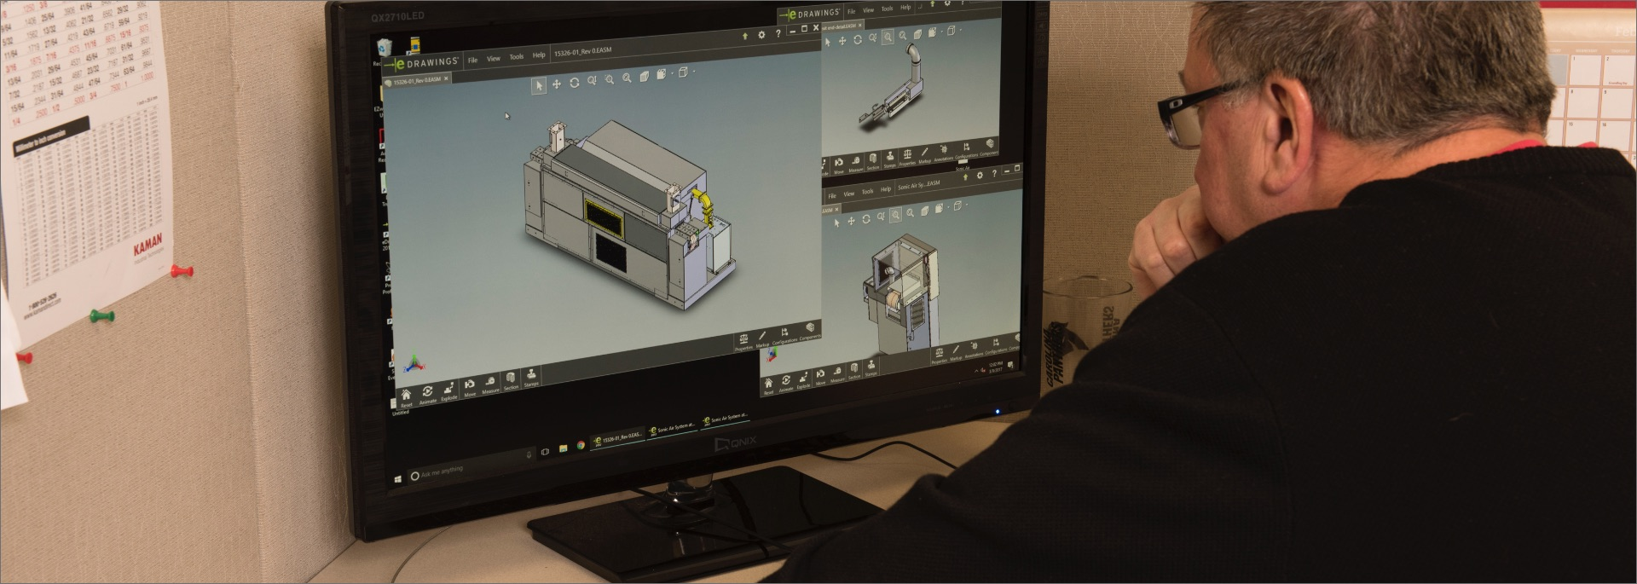

## PROJECT SCHEDULE & TIMELINE

Project schedule and timeline begins with forming a work-breakdown structure (WBS). Once a WBS is defined, dependencies among tasks are defined and finally a schedule is formed.

**SCHEDULE MANAGEMENT**

Schedule management is the process in which we address project time constraint to ensure a timely completion. In planning the schedule, the project team looked at both human labor and activities (sequencing). To identify labor scheduling we will query the project team for known scheduling conflicts and time off. We have built in additional time to account for unplanned schedule conflicts and emergencies. The project team will be identifying the activities, the sequence and dependencies. Where applicable we have estimated the time to complete. Using these estimations we have developed a work breakdown structure. Changes to the schedule will be managed by the project leaders. Change requests will need to be reviewed and unless determined there is no workaround the timeline will not change.

Outputs provided (below) are snapshots of the work breakdown structure and a sample burn down chart for a defined sprint.

**WORK-BREAKDOWN STRUCTURE (WBS)**

The WBS snapshot provided above has been integrated into the project schedule, down to the procurement of staff (resources, talent) and hardware or software requirements. The work breakdown has been grouped into manageable sections throughout the main phases (Initiative, Planning…) and further grouped into multiple sprints in each phase of execution.

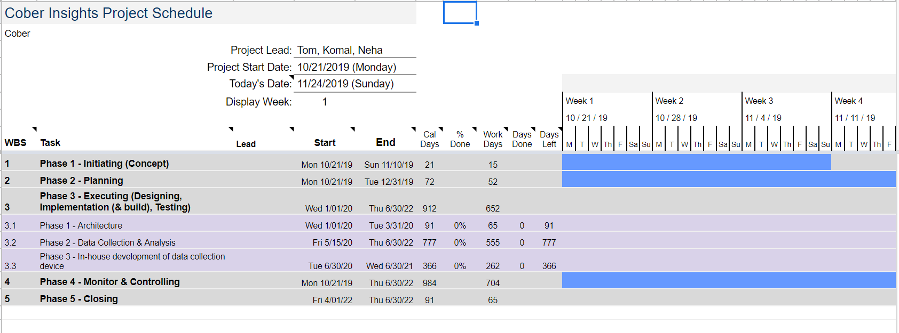

*figure 5. Overview of Work-Breakdown Structure*

**SCRUM MEETING**

Standing scrum meetings are to be held daily with all members of the project team. During the scrum meeting, each member of the team will hold the floor for a brief moment and explain 1. what they worked on the previous day, 2. what they plan on working on that day and 3. any roadblocks to development. It is the goal of team leaders to assist the team member passed the roadblock to continue project development.

**BURNDOWN**

With a record of the tasks completed from each scrum meeting, a burndown chart will be formed in order to represent the number of tasks remaining. The chart should form a curve representing the number of tasks remaining “burning down” to zero.

|  |
| --- |
| **Scrum Meeting Date:** 1/13/2020  **Chickens & Pigs in attendance:** IT, CE  **Objective:** Phase 1 | Sprint 1.1 Cloud Architecture (3.1.2.1)  **Questions to address:**   1. What did you do yesterday?    1. IT: Yesterday, I provided CE access to the Azure Iot Hub    2. CE: Yesterday, I confirmed I have the proper access rights in the Azure IoT Hub 2. What will you do today?    1. IT: Today, I will investigate the message relay system in Azure Iot Hub.    2. CE: Today, I will define all requirements needed for a single connectivity channel between eWon Flexy and Azure Iot Hub. 3. Are there any impediments in your way?*    1. IT: Yes    2. CE: Yes   **\*Impediments raised:**   1. IT: I cannot get in touch with Azure IoT’s message relay support team 2. CE: I have not yet been given access to an existing eWon Flexy device |

*figure 6. Sample SCRUM Meeting Agenda*

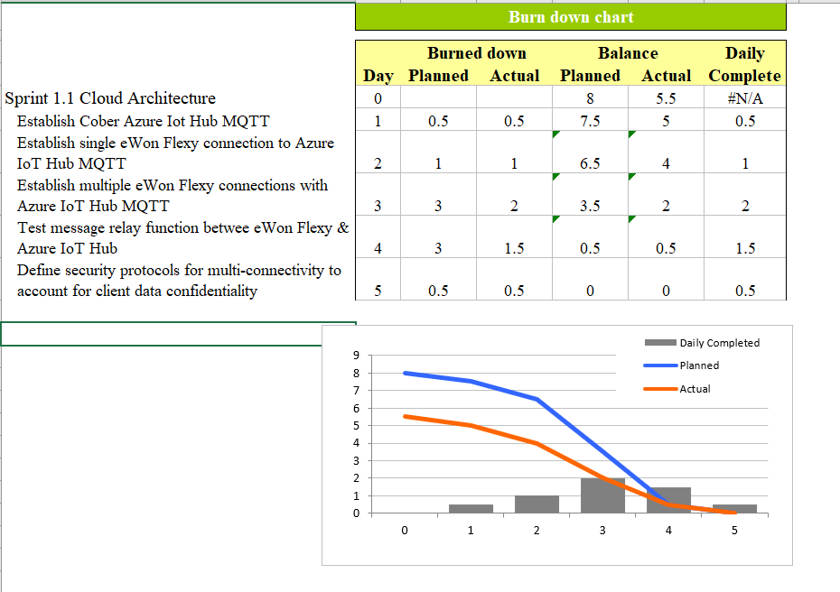

*figure 7. Sample Burndown Chart*

***[ Also see Project Schedule Artifact ]***

## 

## 

## 

## 

figure 8. Project Timeline showing Milestones

## 

## RESOURCE DEFINITION & ALLOCATION

Resource allocation is the process of assigning and managing assets in a way that supports company strategic goals.

**RESOURCE ALLOCATION**

Resource allocation also includes managing tangible assets such as hardware to make the best use of softer assets such as human capital. Competing needs and priorities must be balanced in order to determine the most effective course of action and maximize the effective use of limited resources and best return on investment.

In practicing resource allocation, organizations must first establish their desired end goal, such as increased revenue, improved productivity or better brand recognition. At Cober, resources are allocated as described. They include project manager, business analyst, graphics designer, data analyst etc.

**RESOURCE DEFINITION**

The following professional roles are defined:

**~ PROJECT SPONSOR ~**

The project sponsor has ownership of the project on behalf of the organization.

**~ PROJECT MANAGER ~**

The project managers are accountable for successful delivery of the project on time, on budget, and on scope.

**~ SOFTWARE ENGINEER ~**

The software engineer is responsible for planning, design, implementation and maintenance of software systems.

**~ UX/UI DESIGNER ~**

The UX/UI designer is responsible for the design of clean, front-end user interfaces and a positive user experience.

**~ COMPUTER ENGINEER ~**

The computer engineer is responsible for planning, design, implementation and maintenance of hardware systems.

**~ DATA SCIENTIST ~**

The data scientist must have a strong statistical and analytical background and will be tasked with solving complex business problems with big data.

**~ SOFTWARE QA TESTER ~**

The software QA tester is responsible for internal and external QA. Internal QA includes release and hardware testing activities, such that all functions follow the expected behavior. External QA includes analyzing the application of the solution and qualifying the ability of the solution to meet business objectives.

**~ DATABASE ADMIN ~**

The database administrator is responsible for keeping and maintaining all databases and data stores (datalakes) in the cloud.

**~ IT ADMIN ~**

The IT administrator is responsible for administering all software and hardware systems, maintenance, troubleshooting of equipment, and cloud resource administration.

## 

## MEMBERSHIP ASSIGNMENT

Membership assignment documents task accountability and if the business has the talent or needs to procure the talent in order to complete the project. The method chosen for the Cober Insights project is the RACI Method.

# 

**TEAM ASSIGNMENT**

**Why?** The work assignment allows us to identify the available internal resources for a task, if such resources are not available to look externally and identify possible forgotten resources. In order for a task to be executed it must also be assigned to a specific person, otherwise the project members do not know who is responsible or accountable for that task. The assignment also helps the project leaders pull the right resources for sprints and scrum meetings.

**How?** The project team constructs the assignment as the work breakdown structure and project timeline are being developed. A task is asked three questions: 1) do we need someone from this group on the project 2) do we need them part time or full time 3) can we hire should there be insufficient resources on hand.

The project team is tasked with forming this checklist:

1. What departments need to be involved

* internal, external and customer (alpha’s)

1. Identify a leader from each group

* ensure they understand and have the time to commit to the project

1. Core & Extended members

* Core members are experts in their field and are consulted for decisions and recommendations
* Extended members are task do-ers

1. Resource Potential

* Through the project life cycle the project team looks for complimentary skills and possible potential in resources

**OUTPUT**

The result of the membership assignment process is the following RACI chart. This method was chosen for its visualization of resources and their responsibilities.

**DEFINITIONS**

**R**esponsible - assigned to complete the task

**A**ccountable - person has the final-decision making and ultimately accountable

**S**upport - provides support during task

**C**onsulted - advisor, subject matter expert that can be consulted for various aspects of a tasks

**I**nformed - must be informed after a decision or action

*figure 9. RACI sample from WBS*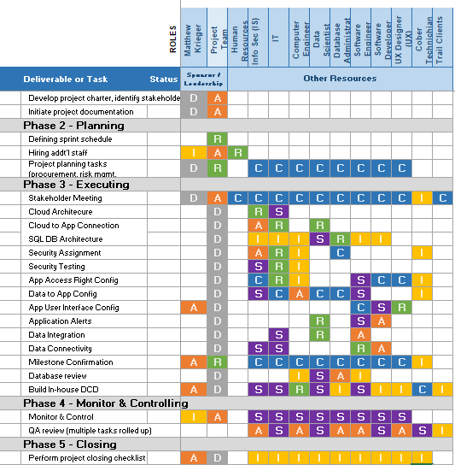

***[ see RACI Matrix artifact ]***

## PROJECT COST ESTIMATE

The following documentation explains the estimated cost that Cober Inc. will incur when starting the Cober Insights Project.

**APPROACH**

This project cost was estimated utilizing a bottom-up approach. Each line item in the work-breakdown structure (WBS) was analyzed, time estimated, and an average cost of professionals was recorded.

Cober project managers are considerate of the overall cost of the Cober Insights project. Therefore, in order to control the major cost of hiring professionals, Cober Insights project managers will seek consultation instead of hiring full-time: Software Development, Software Engineering, Data Scientist, UI/UX Design, Database Admin and Computer Engineer.

**COST ESTIMATION BY PHASE**

In the cost estimation artifact below, the project was broken down according to the work-breakdown structure. The project is divided into the control groups of initiating, planning, executing, monitoring & controlling, and closing. The third control group (executing) is further divided into the three project phases of architecture, data collection & analysis, and in-house development of data collection device.

**PHASE 1 | ARCHITECTURE**

Cost estimation analysis of the first phase, architecture shows an estimated cost of $20,525. In this phase of the project, an initial connection is established between Cober machines and the cloud. Cloud architecture is built and security is established. Because administration of cloud architecture and security are so critical, Cober intends to hire both an IT Administrator and IT Security Practitioner as full time employees. As part of the first phase of the project, a select few clients who utilize Cober machine will be picked to trial the data collection system.

**PHASE 2 | DATA COLLECTION**

In the second phase of the project, *Data Collection & Analysis*, Cober select clients will have their data collected under normal operating conditions. This data will be utilized by Cober to directly enhance the operation of the clients machines, and also enhance future engineering efforts of Cober machines. This is the least costly phase of the project, coming in at only $4,663.

**PHASE 3 | DCD DEVELOPMENT**

In the first two phases of the project, Cober is relying on a preexisting data collection device (DCD) called an eWON Flexy. In order to mitigate costs and risks, Cober intends to create their own data collection device. In this phase of the project, the data collection device is engineered and created, and as well, an application where Cober clients can login and access their data from the web is also created. This is the heaviest costing phase of the project at $250,407. The help from the entire project team will be required. All consultants are needed during this phase of the project.

**CONCLUSION**

In conclusion, the complete cost estimation analysis predicts that the Cober Insights project will require a total of $304,777 across all project activities. Additionally, two full-time IT professionals must also be hired: IT Administrator and IT Security Practitioner. In the following Cost Benefit Analysis, it will become clear that executive sponsors should consider the cost of the project as an investment to improve the Cober customer experience and enhance Cober engineering.

***[ see Project Cost Estimate artifact ]***

## 

## COST BENEFIT ANALYSIS

The project cost benefit analysis is a measure of a project’s costs vs. its benefits to determine a course of action most beneficial to an organization in terms of cost.

**APPLICATION, ACCURACY & PROCEDURE**

A cost benefit analysis allows Cober to weigh the cost and benefit of developing an in-house data collection device and shifting to a service oriented streamline (Data as A Service). Limitations in the accuracy of information are due to Cober’s industry in which there is low volume but high expense. In order to perform a cost benefit analysis, the project team has, through surveys, interviews, and current invoices put together a list of cost estimates. From the 3 year lookout, the year 1 initial cost outweighs the benefits, in part due to Cober not having the talent on staff to begin the shift into the services industry. Much considerations had to be given for the intangibles such as time to market and dependency on sales of DaAS (based on 4 tiers). A deep dive of the analysis steps and breakdown of costs can be found in the artifact.

**DaaS TIER**

A brief of the DaaS tier options has been included due to its material impact on revenue. Since customers can have 1-5 machines or as many as 20. The tier structures include an upsize, new machine and then monthly DaaS package based on number of machines.

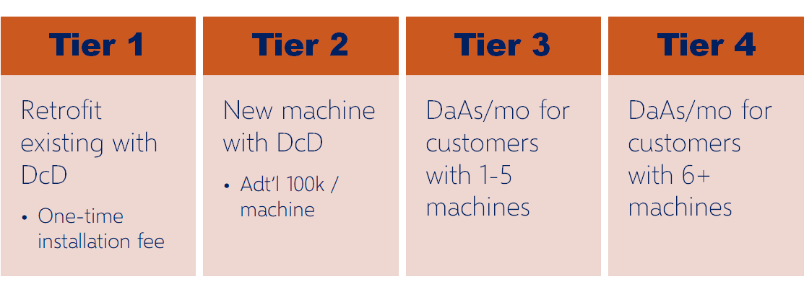

*figure 10. Pricing Tiers*

***[ see CBA, Sample Azure Billing artifact ]***

**COST BENEFIT GROWTH OVER 3 YEAR PERIOD**

***\* benefit represented in green***

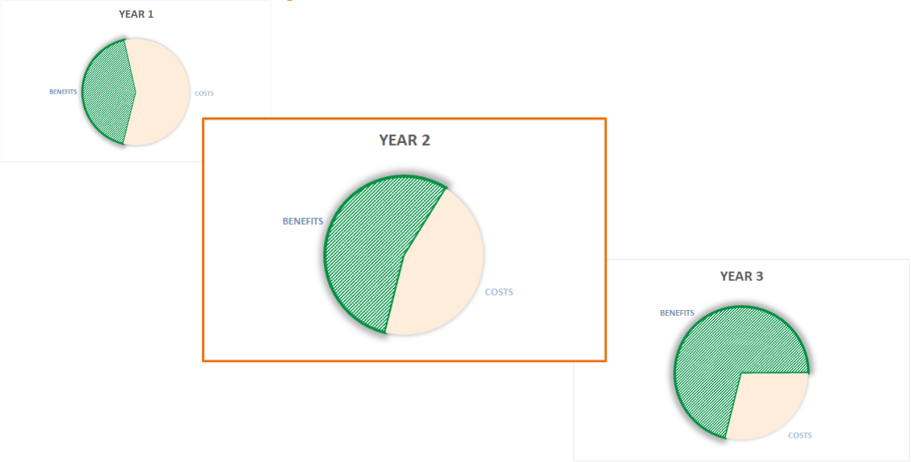

*figure 11. Cost Benefit Breakdown over time*

## RISK ASSESSMENT

A risk assessment points to recognize dangers and assess dangers in arrange to be caught on legitimately and overseen appropriately by giving effective arrangements. The key step interfacing the identification/assessment of dangers with their organization is understanding. The locale where the wander chief or danger pro gets the scarcest help from current rules or sharpen measures. Identification techniques tend to produce unstructured list of risks which do not directly assess the project manager knowing where to focus risk management. Quality assessment can be helpful to identify the risks depending on the probabilities and impacts but it works one at a time and not overall understanding of the risk faced by the project.

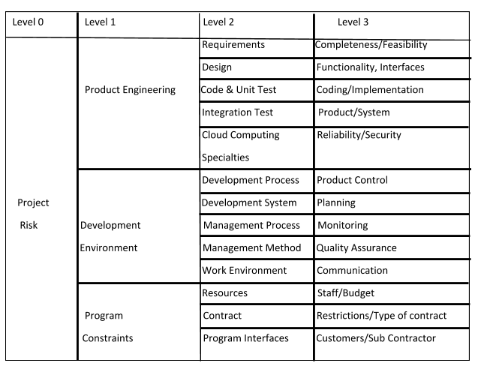

*figure 12. Risk Assessment 1*

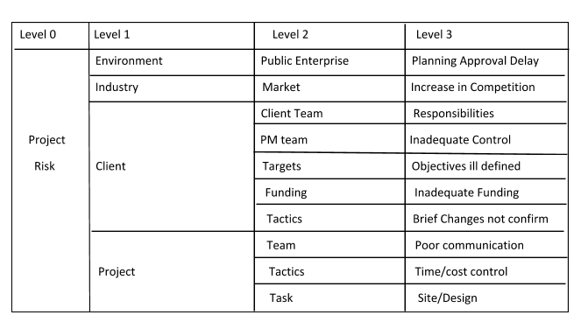

*figure 13. Risk Assessment 2*

**Level 0** - Project Risk

**Level 1** - Major Departments

**Level 2** - Processes within each department

**Level 3** - Risks within each each processes of level 2

**RISK CATEGORIES**

Categorizing risks according to the RBS provides several additional insights into the assessment of risk exposure on the project, which would not be available from a simple list of risks, even if the list were prioritized.

•   Understanding the type of risk exposure on the project.

•   Exposing the most significant sources of risk to the project.

•   Revealing root causes of risk, via affinity analysis.

•   Indicating areas of dependency or correlation between risks.

•   Focusing risk response development on high-risk areas

## QUALITY ASSURANCE OVERVIEW

The purpose of quality assurance is for analyzing and assuring internal and external quality. Quality Assurance professionals are responsible for ensuring that the products and services created during the project are bug-free and follow business strategies and goals. Finally, Quality Assurance is used to mitigate potential risks identified in the previous section.

**QUALITY OBJECTIVES**

Quality objectives are the goals for the value of products, services and processes. Unlike quality policy, quality objectives can be specific to a department, team, process or project. Quality objectives are the measurable goals relevant for enhancing customer satisfaction and are consistent with the quality policy.

1. There should be no problems with authentication for any customer.
2. Customers must have access to previous data.
3. Accurate passing of data should be carried out.
4. System should generate accurate reports for every customer.
5. Data security must be maintained.

**MANAGEMENT**

Quality assurance has defined a cycle called PDCA cycle to ensure that an organization is providing best possible services to customers.

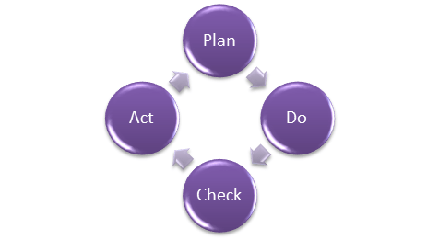

*figure 14. Four Phases of PCDA Cycle*

**PLAN**

Customer operation produces a lot of process data such as time, product information, alerts, operational history and detailed electrical information which can be of value if presented in the form of business intelligence.

**DO**

A web-based application is created for accessing the stored data for fetching data from client’s device we use a data gateway.

**CHECK**

It monitors the data transfer and modifies the process according to the requirements/demand of customers to receive the accurate reports of data.

**ACT**

The concept of CIA triangle is used (Confidentiality, Integrity and Availability) for data, use of eWON Flexy is carried out for fetching data from devices which provides feature of machine alerts.

**QUALITY ASSURANCE FUNCTIONS**

The functions of quality assurance include technology transfer, validation of functionality (software or hardware), documentation of systems, quality of merchandise, and improvement plans.

**TECHNOLOGY TRANSFER**

This operate involves obtaining a product style document similarly as trial and error information and its analysis. The documents are distributed, checked and approved.

**VALIDATION**

Here validation plan for the complete system is ready. Approval of check criteria for substantiating product and method is ready. Resource coming up with for execution of a validation set up is finished.

**DOCUMENTATION**

This operate controls the distribution and archiving of documents. Any modification in a very document is created by adopting the right change management procedure. Approval of all sorts of documents.

**QUALITY OF MERCHANDISE**

The reason of quality affirmation is to form certainty that the quality arranges, and controls are working appropriately. To guarantee quality, time must be distributed to survey the first quality arrange and compare that arrange to how quality is being made amid the execution of the extend.

**QUALITY IMPROVEMENT PLANS**

A Quality improvement plans are an organization's system for creating and making strides forms. It incorporates the course, timeline, exercises, and evaluation measures of quality and quality advancement inside the organization.

**START GROUPS**

Quality Assurance will facilitate start groups to clarify the goal and be tracked to truly reach that goal while not an excessive amount of deviation. Additionally, it helps clarify the responsibilities of each role concerned into the merchandise development lifecycle.

*[ this page left intentionally blank ]*

# 

# 

# 

# ARTIFACTS

# 

|  |  |  |  |
| --- | --- | --- | --- |
| SCOPE TABLE v2.1 | | | |
| **Project Name** | Cober Insights | | |
| **Project Sponsor** | Mathew Krieger | **Project Manager** | Thomas Birmingham |
| **SCOPE DESCRIPTION** | The Cober Insights project consists of three phases. Phase 1 will consist of the development of an application compatible with the data collection device. Phase 2 will broken into two sub phases. Main subphase 2A will be the sourcing of additional talent to round out the project team as well as identifying existing clients to be trial clients. Phase 2B will be the collection of data for a one year period starting in Q2 2020. Phase 3 in conjunction with the data analysis, will see a technology investment at Cober for an in-house data collection device.  This project will allow Cober an advantage in the data as a service in the manufacturing sector adding value in the areas of predictive maintenance, process optimization and product output. Cober Insights will be completed June 30, 2021. | | |
| **PROJECT DELIVERABLES** | 1. Online web application accessible by clients for machine metrics 2. A data-collection device able to capture all points currently tracked by Flexy | | |
| **REQUIREMENTS** | * Investment in technology and technology staffing * Data gathering and analysis to feed AI forecasting models * Willing and communicative trial clients | | |
| **ACCEPTANCE CRITERIA** | **Cober**   * Meet deliverables within time and budget * Gather one year of client data to be fed into application * Develop in-house data collection device no longer relying on Flexy * Faster proactive deployment of machine technicians   **Customer**   * Initial reduction in scrap by 1% within the first year of data gathered * Initial reduction in machine part failure by 2% over prior years servicing request * Reduce machine downtime by 5% at the end of year one years | | |
| **CONSTRAINTS** | **Time**: during the one year period of data gathering and analysis  **Budget**: additional resources and talent must be sourced outside Cober | | |
| **ASSUMPTIONS** | **Resources**: end user (client) will be able to test and provide feedback to Cober IT/Software developers during Phase 2  **Delivery**: data collection device software specifications will be catalogued within the next two months based on existing expertise  **Schedule**: sufficient data will be gathered in one year to allow for artificial intelligence and machine learning to generate forecasting events  **Technology**: 50% of software development can be completed by COBER IT/Software Developers, Electrical/Mechanical engineers and Machine technicians | | |

|  |  |  |  |  |  |
| --- | --- | --- | --- | --- | --- |
| PROCESS GROUP MATRIX v2.0 | | | | | |
| **Knowledge Area** | **PROCESS GROUPS** | | | | |
|  | **Initiating** | **Planning** | **Executing** | **Monitor & Controlling** | **Closing** |
| **Integration Management** | development of project charter | initiate project management plan | identifying project work | defining and performing change control & monitoring project/task status | confirm meeting of acceptance criteria  determine final documentation |
| **Scope Management** |  | scope planning, collect requirements | estimate activity costs | scope oversight & control to limit scope creep, monitor deliverable progress | keep documented changed log |
| **Time Management** |  | define activities, sequencing and dependencies, estimate resources |  | control schedule |  |
| **Cost Management** |  | estimate cost baseline, plan for cost management |  | control cost |  |
| **Quality Management** |  | plan testing events | test/perform QA | set and control level of testing to be achieved | document testing results |
| **Human Resources Management** |  | HR planning | acquire, develop, and manage team |  |  |
| **Communication Management** |  | communication management | manage project communication | control communication channels and frequency |  |
| **Risk Management** |  | identify risks, appetite and tolerance |  | control risk |  |
| **Procurement Management** |  | perform procurement analysis | conduct procurement | control procurement | close any open procurement items |
| **Stakeholder Management** | identify stakeholder | create stakeholder management plan | manage engagement | control engagement |  |

|  |  |  |  |  |  |  |
| --- | --- | --- | --- | --- | --- | --- |
| PROCESS METHODOLOGY & DEFINITION MATRIX V2.0 | | | | | | |
| **Process** | **Owner** | **Activities** | **Inputs** | **Outputs** | **Monitoring** | **Criteria for Effectiveness** |
| **1. Strategic Planning** | General Manager  Project Lead | Risk Analysis  Strategic Planning | Risks  Customer feedback  Organization vision  Past experience | Business Plan  Key measures | Internal Audit  Business review meetings | Achievement of business plan  Improvement of key measures  Net income |
| **2. Marketing** | General Manager  Project Lead | Explore new product opportunities | Customer feedback  Past experience | Marketing media  Design inputs | Internal Audit  Business review meetings | Revenue growth  Net income |
| **3. Application Design & Development** | Software Developer  UX Designer  Security Specialist | Software Requirements Elicitation | Software Requirements | Wireframes  Designs  Class Diagrams | Internal Audit  Weekly Project Status Meeting | % of revenue from products and services |
| **4. Data Analytics** | Data Scientist | Data Modelling  Analysis | Data  Algorithms | Data Model  Insights | Internal Audit  Weekly Project Status Meeting | % of revenue from products and services |
| **5. Data Collection Device**  **Design and Development** | Computer Engineer  Systems Architect  Security Specialist | Blueprinting  Planning  Designing | Hardware Specifications  Constraints  Designs  Requirements | Physical Device  Specifications  Hardware | Internal Audit  Weekly Project Status Meeting | % of revenue from products and services |
| **6. Application Deployment** | IT Admin | Deploy | Code | Published Application | Internal Audit | % on time delivery |
| **7. Customer Satisfaction** | General Manager  Project Lead | Interviewing | Survey | Customer Feedback | Internal Audit  Business review meetings | Revenue growth  Net income |
| **8. Business Review** | General Manager | Review Implementation | Business Plan  Performance Data  Key Measures | Business plan revisions  Strategic decisions | Internal Audit | Achievement of business plan  Improvement of key measures  Net income |

|  |  |  |  |  |  |  |
| --- | --- | --- | --- | --- | --- | --- |
| STAKEHOLDER POWER & INTEREST CHART v1.0 | | | | | | |
| **Key** | **Organization** | **Name** | **Influence Level** | **Interest Level** | **Risk Level** | **Communication Strategy** |
| A | Project Sponsor  Info Sec / Info Tech  Soft Dev | Krieger | 1 | 1 | 1 | Bi-weekly |
| B | Mechanical Engineers | Peacock | 4 | 3 | 4 | Quarterly |
| C | Maintenance / H&D Technicians | Plum | 2 | 2 | 3 | Quarterly |
| D | DBMA / Comp Eng | Boddy | 3 | 1 | 1 | Weekly |
| E | Data Scientist | White | 2 | 1 | 1 | Weekly |
| F | eWon Flexy (Vendor) | Mustard | 2 | 2 | 4 | Minimal |
| G | Trial Customers (Existing) | Green | 4 | 3 | 4 | Quarterly |
| H | New Customers |  | 5 | 3 | 5 | Bi-annual |
| I | Government |  | 5 | 5 | 5 | Annual |
| *\*Scoring between 1 and 5; 5 being the lowest* | | | | | | |

|  |  |  |  |  |
| --- | --- | --- | --- | --- |
| RESOURCE ALLOCATION v2.1 | | | | |
| **Task** | **Role** | **Start Date** | **End Date** | **Duration (in days)** |
| **Planning Stage** | Project Manager | 02/06/2019 | 02/25/2019 | 19 |
| Identify Stakeholders | Business Analyst | 02/06/2019 | 02/25/2019 | 19 |
| Requirement Gathering | Business Analyst | 02/06/2019 | 02/25/2019 | 19 |
| Establish Cost Schedule | Business Analyst | 02/06/2019 | 02/25/2019 | 19 |
| Establish list of deliverables | Business Analyst | 02/06/2019 | 02/25/2019 | 19 |
| Using an external device | Software Engineer | 02/06/2019 | 02/25/2019 | 19 |
| Cloud Acquisition | Solution Architect | 02/06/2019 | 02/25/2019 | 19 |
| Documentation | Business Analyst | 02/06/2019 | 02/25/2019 | 19 |
| **Analysis Stage** | Project Manager | 02/12/2019 | 02/29/2019 | 17 |
| Data Analysis | Data Scientist | 02/12/2019 | 02/29/2019 | 17 |
| Problem Analysis | Data Scientist | 02/12/2019 | 02/29/2019 | 17 |
| Analysis of external device | Software Developer | 02/12/2019 | 02/29/2019 | 17 |
| **Design Stage** | Project Manager | 02/18/2019 | 03/13/2019 | 24 |
| System Architecture | System Architect | 02/18/2019 | 03/13/2019 | 24 |
| Front End Designing | Front End Designer | 02/18/2019 | 03/13/2019 | 24 |
| Back End Designing | Software Developer | 02/18/2019 | 03/13/2019 | 24 |
| UI/UX Designing | UI/UX designer | 02/18/2019 | 03/13/2019 | 24 |
| **Development Stage** | Project Manager | 03/08/2019 | 04/15/2019 | 38 |
| Software Engineering | Software Engineer | 03/08/2019 | 04/15/2019 | 38 |
| Software Development | Software Engineer | 03/08/2019 | 04/15/2019 | 38 |
| Cloud Setup & Integration | Database Administrator | 03/08/2019 | 04/15/2019 | 38 |
| Dashboard creation | Software Engineer | 03/08/2019 | 04/15/2019 | 38 |
| Database Creation | Database Developer | 03/08/2019 | 04/15/2019 | 38 |
| **Quality Assurance Stage** | Project Manager | 04/10/2019 | 05/03/2019 | 23 |
| Regression Testing | Software Tester | 04/10/2019 | 05/03/2019 | 23 |
| User Acceptance testing | Software Tester | 04/10/2019 | 05/03/2019 | 23 |

|  |  |  |  |  |  |  |  |  |
| --- | --- | --- | --- | --- | --- | --- | --- | --- |
| PROJECT COST ESTIMATION v2.0 | | | | | | | | |
| **WBS #** | **WBS Categories** |  | **Labor (#hours)** | **$/hr** | **$ Total** | **Labor $** | **Non-labor $** | **Total Cost** |
| **1** | **INITIATING** |  |  |  |  |  |  |  |
| 1.1 | Develop Project Charter | TKN | 25 | $65 | **$1,625** | **$1,625** |  | $1,625 |
| 1.2 | Identify Stakeholders | TKN | 25 | $65 | **$1,625** | **$1,625** |  | $1,625 |
| 1.3 | Initiate project documentation | TKN | 25 | $65 | **$1,625** | **$1,625** |  | $1,625 |
| 2.1 | Team planning meeting | TKN | 3 | $65 | **$195** | **$195** |  | $195 |
| 2.1.1 | Define sprint schedule | TKN | 3 | $65 | **$195** | **$195** |  | $195 |
| 2.2 | Scope Management | TKN | 3 | $65 | **$195** | **$195** |  | $195 |
| 2.2.1 | Prepare and define scope | TKN | 3 | $65 | **$195** | **$195** |  | $195 |
| 2.3 | Human Resource Management | TKN, HR/MK | 4 | $85 | **$340** | **$340** |  | $340 |
| 2.3.8 | Schedule First Townhall to introduce project team members | TKN | 1 | $65 | **$65** | **$65** |  | $65 |
| 2.4 | Collect requirements | TKN | 40 | $65 | **$2,600** | **$2,600** |  | $2,600 |
| 2.4.1 | Estimate activities requirements (non-labour) | TKN | 40 | $65 | **$2,600** | **$2,600** |  | $2,600 |
| 2.4.2 | Prepare requirement change request process | TKN | 4 | $65 | **$260** | **$260** |  | $260 |
| 2.5 | Schedule Management | TKN | 4 | $65 | **$260** | **$260** |  | $260 |
| 2.5.1 | Review individual resource schedules (ie. vacations, known busy periods...) | TKN | 4 | $65 | **$260** | **$260** |  | $260 |
| 2.5.2 | Define activities | TKN | 4 | $65 | **$260** | **$260** |  | $260 |
| 2.5.2.1 | Sequence activities | TKN | 4 | $65 | **$260** | **$260** |  | $260 |
| 2.5.3 | Identify activities dependencies | TKN | 4 | $65 | **$260** | **$260** |  | $260 |
| 2.5.4 | Estimate activities resources (labour) | TKN | 4 | $65 | **$260** | **$260** |  | $260 |
| 2.5.5 | Estimate activities duration | TKN | 4 | $65 | **$260** | **$260** |  | $260 |
| 2.5.5.1 | Prepare and define schedule | TKN | 4 | $65 | **$260** | **$260** |  | $260 |
| 2.6 | Prepare estimate of cost baseline | TKN, MK | 4 | $85 | **$340** | **$340** |  | $340 |
| 2.6.1 | Estimate activities cost (labour and non-labour) | TKN | 4 | $65 | **$260** | **$260** |  | $260 |
| **2.7** | **Risk Management** |  |  |  |  |  |  |  |
| 2.7.1 | Prepare risk management questionnaire for brainstorming session | TKN | 4 | $65 | **$260** | **$260** |  | $260 |
| 2.7.2 | Identify risk | TKN | 16 | $65 | **$1,040** | **$1,040** |  | $1,040 |
| 2.7.2.1 | Define risk appetite & intolerance | TKN, MK | 2 | $85 | **$170** | **$170** |  | $170 |
| 2.7.3 | Perform qualitative risk analysis | TKN | 4 | $65 | **$260** | **$260** |  | $260 |
| 2.7.4 | Perform quantitative risk analysis | TKN, MK | 4 | $85 | **$340** | **$340** |  | $340 |
| 2.7.5 | Document response plan | TKN | 8 | $65 | **$520** | **$520** |  | $520 |
| 2.7.6 | Identify possible fallback plan | TKN | 8 | $65 | **$520** | **$520** |  | $520 |
| 2.8 | Procurement Management | TKN | 8 | $65 | **$520** | **$520** |  | $520 |
| 2.8.1 | Plan & Conduct third party analysis for external resources (eWon Flexy alternative) | TKN | 4 | $65 | **$260** | **$260** |  | $260 |
| 2.8.1.1 | Control procurement (manage contract) | TKN | 4 | $65 | **$260** | **$260** |  | $260 |
| 2.8.1.2 | Close procurement (ensure proper execution of contract) | TKN | 4 | $65 | **$260** | **$260** |  | $260 |
| 2.8.2 | Plan & Conduct third party analysis for external resources (Azure) | TKN | 4 | $65 | **$260** | **$260** |  | $260 |
| 2.8.2.1 | Control procurement (manage contract) | TKN | 4 | $65 | **$260** | **$260** |  | $260 |

|  |  |  |  |  |  |  |  |  |
| --- | --- | --- | --- | --- | --- | --- | --- | --- |
| **WBS #** | **WBS Categories** |  | **Labor (#hours)** | **$/hr** | **$ Total** | **Labor $** | **Non-labor $** | **Total Cost** |
| 2.8.2.2 | Close procurement (ensure proper execution of contract) | TKN | 4 | $65 | **$260** | **$260** |  | $260 |
| 2.9 | Milestone Mapping | TKN | 4 | $65 | **$260** | **$260** |  | $260 |
| 2.9.1 | Survey project team for possible milestone identifiers | TKN | 4 | $65 | **$260** | **$260** |  | $260 |
| 3.1.1 | Meeting to discuss stakeholder needs and concerns with architecture (ie. security, reporting templates...) | TKN, StkHld | 16 | $65 | **$1,040** | **$1,040** |  | $1,040 |
| 3.1.5.1 | Survey key stakeholders for needs and data visualization suggestions (ie. branding) | TKN, StkHld | 25 | $65 | **$1,625** | **$1,625** |  | $1,625 |
| 3.2.6 | **SPRINT 2.2 Milestone Confirmation** |  |  |  |  |  |  |  |
| 3.2.7 | Milestone 1 - supporting metrics for a 1% reduction in scrap | TKN | 1 | $65 | **$65** | **$65** |  | $65 |
| 3.2.8 | Milestone 2 - supporting metrics to determine machine maintenance trends | TKN | 1 | $65 | **$65** | **$65** |  | $65 |
| 3.2.9 | Milestone 3 - confirm sufficient data to being predictive forcasting | TKN | 1 | $65 | **$65** | **$65** |  | $65 |
| 3.2.11 | Collect 1 years worth of data | TKN | 8 | $65 | **$520** | **$520** |  | $520 |
| 3.3.5 | Prepare resolutions to be input into in-house dcd | TKN | 4 | $65 | **$260** | **$260** |  | $260 |
| 3.3.8.1 | **SPRINT 3.3 In-house DCD to achieve milestones** |  |  |  |  |  |  |  |
| 3.3.8.2 | Milestone 1 - supporting metrics for a 1% reduction in scrap | TKN | 1 | $65 | **$65** | **$65** |  | $65 |
| 3.3.8.3 | Milestone 2 - supporting metrics to determine machine maintenance trends | TKN | 1 | $65 | **$65** | **$65** |  | $65 |
| 3.3.8.4 | Milestone 3 - confirm sufficient data to being predictive forcasting | TKN | 1 | $65 | **$65** | **$65** |  | $65 |
| 3.4 | **SPRINT 3.5 Documentation** | TKN |  |  |  |  |  |  |
| 3.5 | Provide internal personel with documented training material | TKN | 8 | $65 | **$520** | **$520** |  | $520 |
| 3.6 | Draft new client demonstration of application & reporting packages | TKN | 8 | $65 | **$520** | **$520** |  | $520 |
| 4.1 | Initial Monitor & Control meeting | TKN | 4 | $65 | **$260** | **$260** |  | $260 |
| 4.1.1 | Determine communication plan (format and frequency) | TKN | 4 | $65 | **$260** | **$260** |  | $260 |
| 4.1.2 | Determine who needs to be communicated to (poss. sub frequency communications based on stakeholder involvement) | TKN | 4 | $65 | **$260** | **$260** |  | $260 |
| 4.3 | Document resolutions to failed testing | TKN | 4 | $65 | **$260** | **$260** |  | $260 |
| 4.5 | Document results & version | TKN | 4 | $65 | **$260** | **$260** |  | $260 |
| 4.6 | Schedule periodic review of in-house dcd & application for poss. enhancements, address user feedback issues | TKN | 4 | $65 | **$260** | **$260** |  | $260 |
| 5.1 | Confirm work is done as per requirements | TKN | 8 | $65 | **$520** | **$520** |  | $520 |
| 5.2 | Complete the procurement closing process | TKN | 8 | $65 | **$520** | **$520** |  | $520 |
| 5.3 | Confirm formal acceptance (based on acceptance criteria noted in scope) | TKN | 8 | $65 | **$520** | **$520** |  | $520 |
| 5.4 | Complete final performance reporting documentation | TKN | 8 | $65 | **$520** | **$520** |  | $520 |
| 5.5 | Index & archive results | TKN | 2 | $65 | **$130** | **$130** |  | $130 |
| 5.6 | Perform lessons learned meeting | TKN | 8 | $65 | **$520** | **$520** |  | $520 |

## RACI ARTIFACT v2.0

